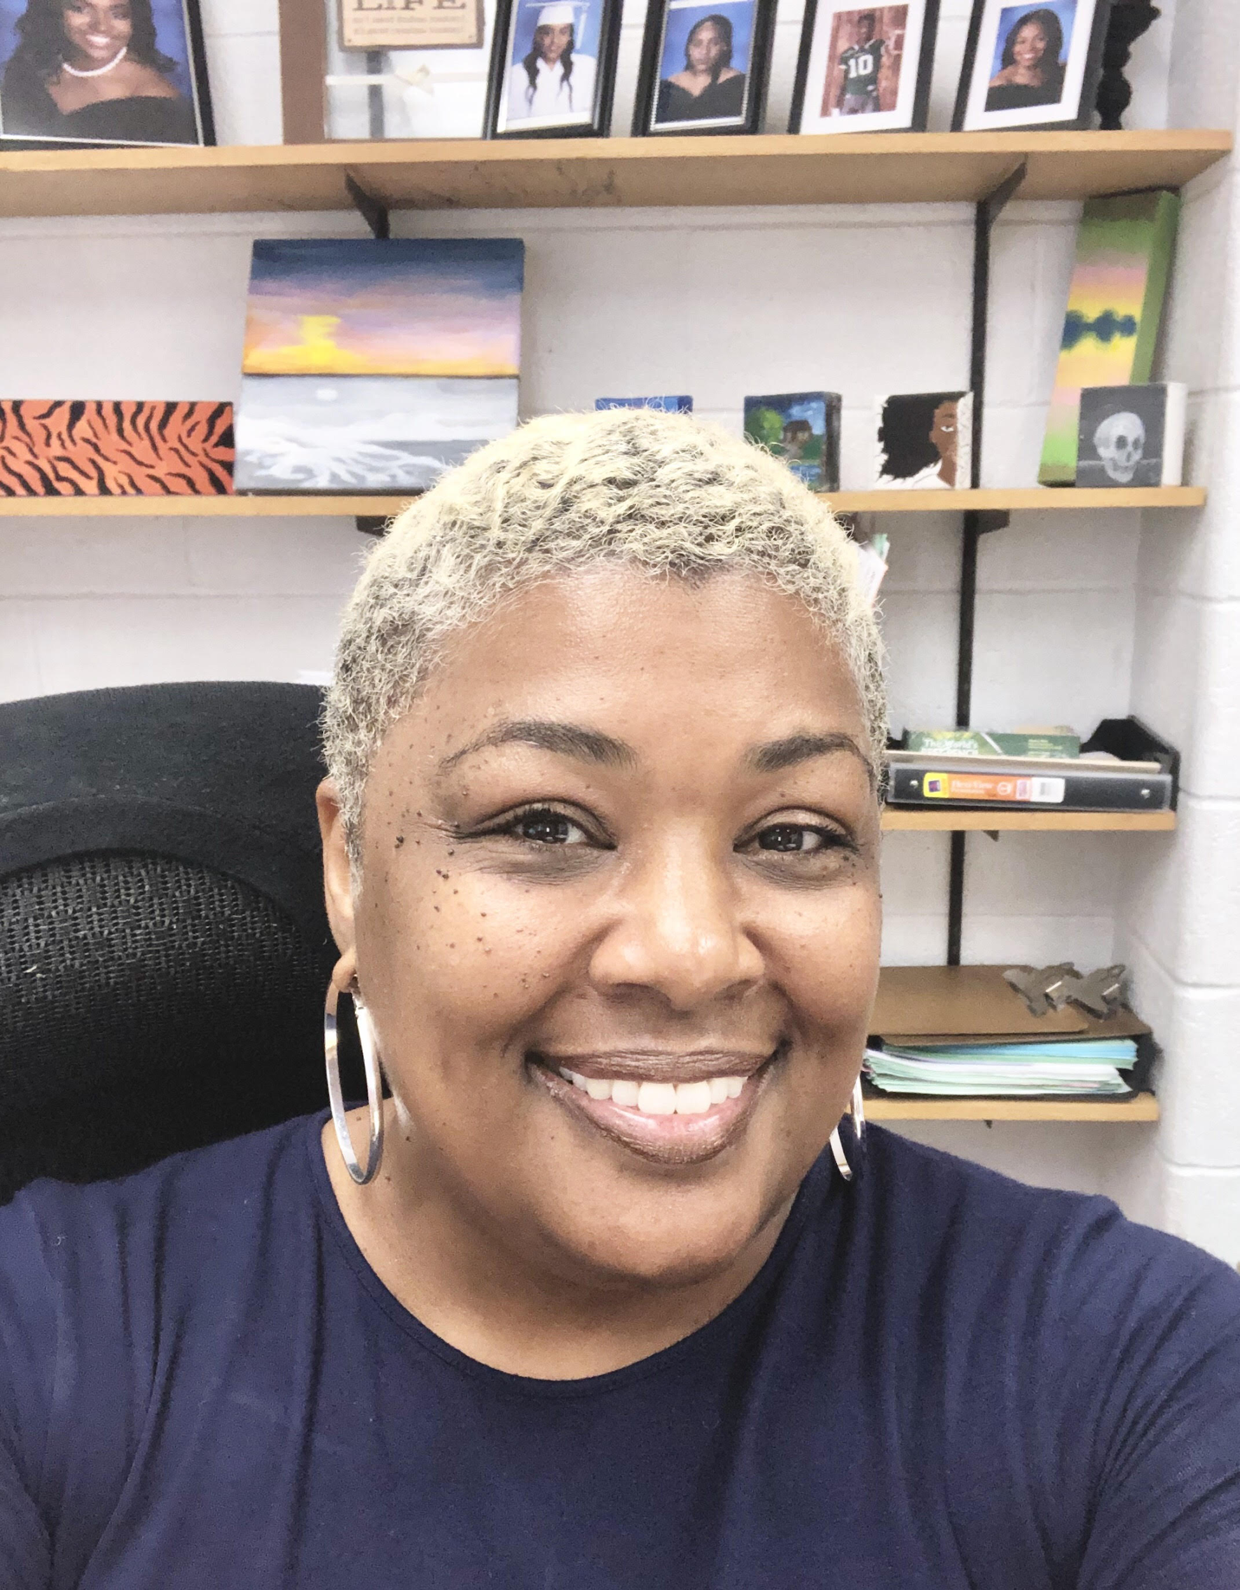
Dear Parents and Guardians,
I am excited to be working with you and your family this year as your child’s professional school counselor. With 28 years of experieince in education as a former classroom teacher and program coordinator, I bring a wealth of knowledge and experience to my role as a counselor. As I begin my 7th year at Surrattsville, I hope to continue to support students through a guidance program that is focused on student achievement and growth.
Counseling Curriculum: Counseling services in a high school setting include individual counseling, group counseling, academic advisement, and college & career planning. Students are supported through monthly classroom guidance, workshops, and counseling sessions. We follow a counseling plan, developed by our counselors, to implement our guidance curriculum. The information we cover and our focus each year is based upon data we have collected from the previous year.
Communication: I communicate regularly with students and parents to share important information. I have established a google classroom for each grade level that I support. All classroom guidance lessons and important updates are shared in the classroom with students. For parents there are several tools. Our department uses our website, Twitter, and weekly email to share updates with parents. For senior parents, we have developed a Class of 2020 Website where all pertinent iformation can be found.
Making an appointment: If the need arises during the school year for you to meet with me or be in conctact, email is the quickest way to reach me. If you need to meet in person, having an appointment will ensure that I am available and prepared for our meeting. You can set up an appointment by emailing me.
The school counseling program is for all students. Our school’s program is developmental, preventitive and proactive. I look forward to continuing to work with you this year to ensure your child’s success. Be sure to check out my email auto reply and our website for imporatant dates and information on all of our events. Don’t hesitate to call, email, or drop by for assistance at any time.
Counseling Department Mission Statement:

The Counseling Department staff works collaboratively with all stakeholders to provide a safe and orderly environment that is conducive to higher education, promotes student excellence and achievement, and prepares students to be lifelong learners who participate in a global society.

Some reasons to See Your Counselor:

- Academic Skills Support
- Career Preparation
- Postsecondary planning and college application process
- Coping, problem-solving, decision-making concerns
- Organizational, study and test taking skills
- Peer relationships and conflict resolution problems
- School-based and community resources information or referrals

Counseling Department Goals:

- To assist students with educational, personal, career and goal planning
- To help students understand themselves and others
- To facilitate the idenification of students with special needs
- To provide crisis intervention when necessary
- To coordinate referrals to school and community support services
- To serve as a resource to students, parents, teachers,and administators

Kirsten S. Simpkins
Professional School Counselor
Caseload: Grades 11 & 12

Email: kirste.simpkins@pgcps.org
Twitter: Counselors@surratthornets
Webpage: surrattsvillecounseling.weebly.com

